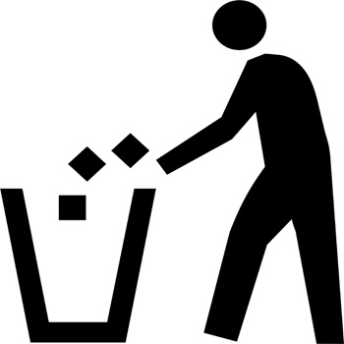 | Using the bin | 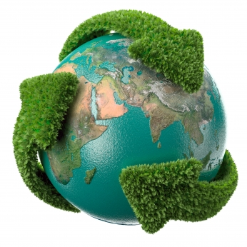 | Recycling | 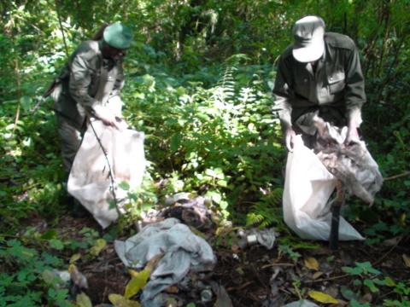 | Cleaning the forests
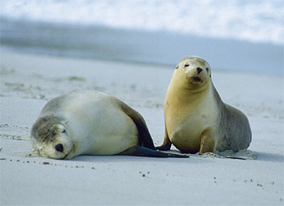 | Protecting the animals | 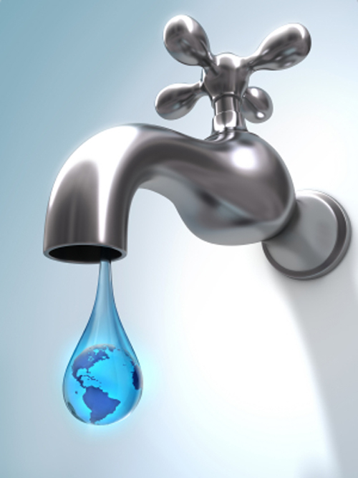 | Sparing water | 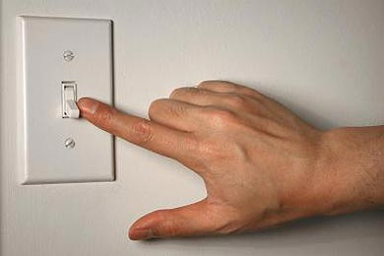 | Switching off the light
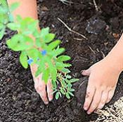 | Planting trees | 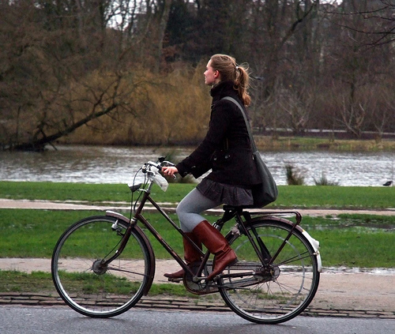 | Riding bikes | (add one more ) | Looking for alternative energy sources


- Observe the following pictures and look for possible solutions to the environmental problems we have today in the recycled book placed below. Add any another solution you recall.
Ficha 8

ESCOLA SECUNDÁRIA EÇA DE QUEIRÓS
School Year 20___/ 20__
English
Name: Pedro Aurélio·· Class: S - 13

THE ENVIRONMENT - LOOK AROUND YOU ... Teacher: Teresa Rafael

Name: __________________________________________ Class: _____ Date: ________

Teacher: Teresa Rafael

x | q | p | p | u | i | m | a | c | f | g | p | o | u | s | a | d | i | x | r
a | c | l | e | a | n | i | n | g | t | h | e | f | o | r | e | s | t | s | í
c | o | a | a | l | j | f | b | w | x | z | i | t | b | n | a | p | c | y | c
k | i | n | b | r | v | r | j | m | s | t | g | c | q | h | p | a | i | p | z
u | v | t | t | e | q | f | v | e | r | s | h | n | s | q | d | r | p | u | a
s | w | i | t | c | h | i | n | g | o | f | f | t | h | e | l | i | g | h | t
e | b | n | q | y | f | o | y | v | a | c | e | r | a | r | c | n | g | d | e
z | c | g | á | c | g | a | r | u |  | f | c | k | o | d | p | g | a | a | r
w | i | t | r | l | h | y | d | s | z | v | i | g | p | t | i | w | r | r | r
r | c | r | b | i | b | i | v | l | f | a | c | y | c | o | r | a | l | d | í
t | l | e | o | n | b | y | n | v | c | h | l | t | g | q | b | t | a | e | p
o | a | e | l | g | c | i | e | q | y | u | a | e | x | b | o | e | l | l | f
j | r | s | e | m | s | o | n | a | c | o | r | r | a | r | a | r | u | a | e
u | q | v | n | k | x | a | t | r | l | e | j | y | l | u | x | t | b | o | e
s | u | l | s | z | a | d | u | s | i | n | g | t | h | e | b | i | n | i | h
b | v | g | f | s | t | m | b | c | n | o | z | s | i | x | d | f | i | r | a
p | r | o | t | e | c | t | i | n | g | t | h | e | a | n | i | m | a | l | s
Good Luck ☺

